Code:

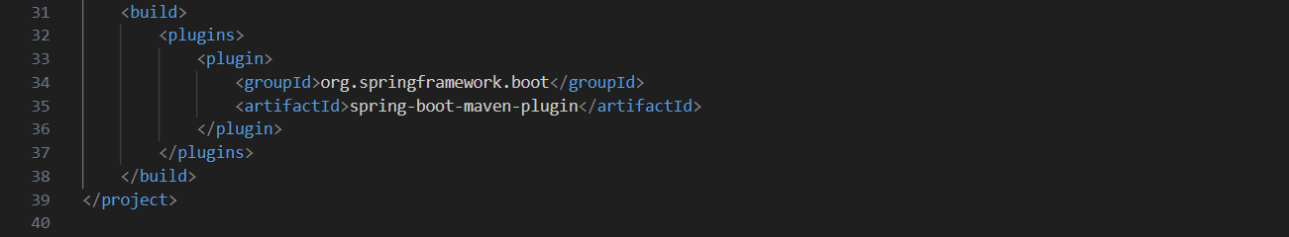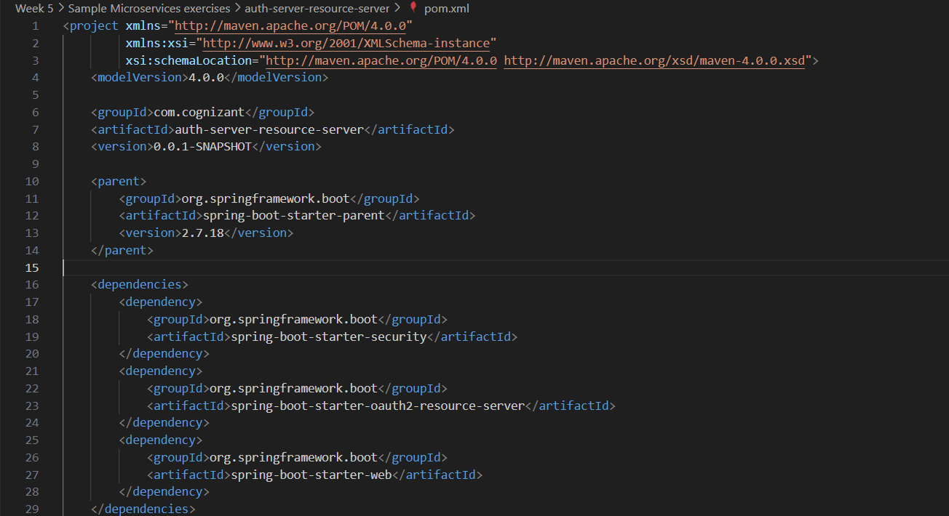pom.xml

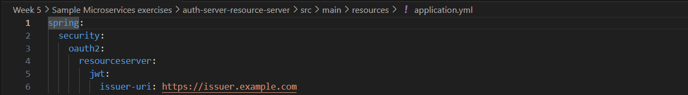application.yml

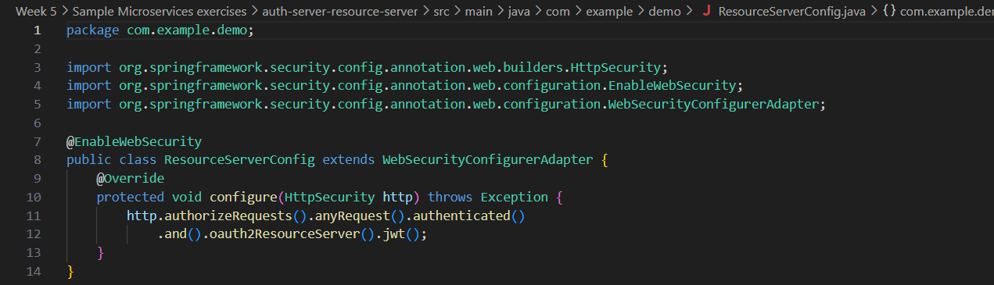ResourceServerConfig.java

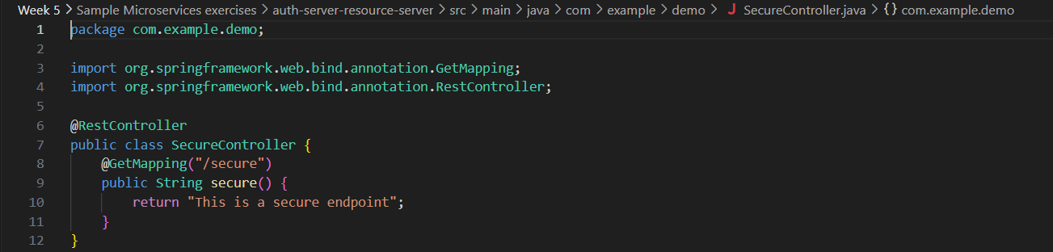SecureController.java